
DIVISION OF FINE ARTS
DEPARTMENT OF MUSIC

SPRING SING 2026
DELIVERANCE

featuring
A Cappella Choir
GilaSoul Singers
Resonus
Revue Show Choir
Symphonic Choir
Vocal Jazz Ensemble

Friday, April 24, 2026 | 7 p.m.
Saturday, April 25, 2026 | 1 p.m.
Fine Arts Auditorium
Eastern Arizona College
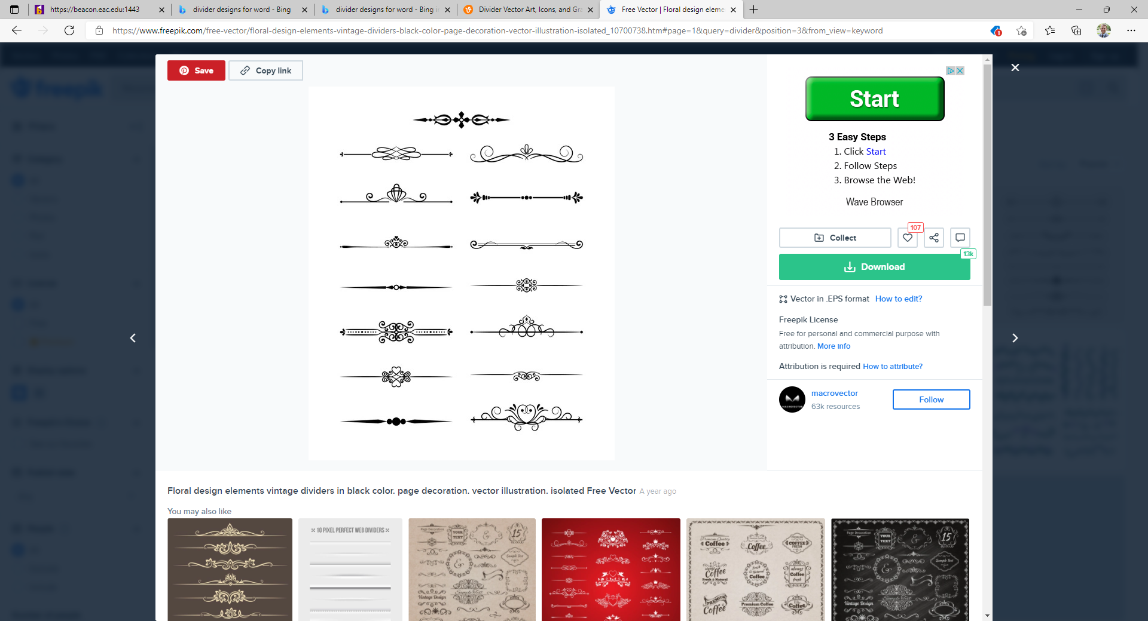

Remember to turn off/silence all electronic and other noise-making devices.
Also, please enter/exit only during the applause.
Thank you for your cooperation and for your support of the arts
at Eastern Arizona College.

PROGRAM

Show Choir

Magic to Do Stephen Schwartz (b. 1948)
from Pippin
Elise Densmore, Teegan Nashio, Alex Smith, Caddy Bigler,
Danielle Stevenson, Cordon Smith, & Hayden Morrow, soloists

Run Freedom Run Mark Hollman (b. 1963)
from Urinetown arr. Andrew M. Wallace
Sam John & Alex Smith, soloist

Part of the Human Heart Lynn Aherns & Stephen Flarety
from Once on This Island arr. Bruce Bishop
Lacy Deets, soloist

Nobody Richard Oberacker
from Bandstand
Hayden Morrow, Teegan Nashio, Cordon Smith,
& Lacy Deets, soloists

Light Tom Kitt (b. 1974)
from Next to Normal arr. Lisa DeSpain (b. 1964)
Danielle Stevenson, Elise Densmore, Hayden Morrow,
& Caddy Bigler soloists

Footloose Kenny Loggins (b. 1948)
from Footloose arr. Kirby Shaw (b. 1941)
Sam John, soloist

Vocal Jazz Ensemble

W.I.T.C.H. Devon Cole & John Mark Nelson
arr. Emily Drum (b. 1998)
percussion by Mikell Decker (b.1988)

Simple Life Harry Ruby & Rube Bloom
arr. Jennifer Barnes

My Mother Told Me Perły i Łotry
arr. Patty Raines

Softest Rains Rob Dietz (b. 1987)

Combined Choirs

“Coro di Schiavi Ebrei” Giuseppe Verdi (b. 1813-1901)
(Va, pensiero), from Nabucco

Resonus

It’s The Music That Brings Us Together Clay Hine (b. 1963)

Amazing Grace John Newton (1725-1807)
arr. Robert T. Gibson (b. 1989)
Franklin Alvarez, violin; Liam Clark, cello

GilaSoul Singers & Resonus

Non Nobis Domine Rosephanye Powell (b. 1962)

The Impossible Dream Joe Darion (1911-2001) &
from Man of La Mancha Mitch Leigh (1928-2014)
arr. Mark Hayes (b. 1953)

GilaSoul Singers

I Am Not Yours David N. Childs (b. 1969)

Dear John, Dear John Stephen M. Hopkins

A Cappella Choir

I

Trinity Te Deum Ēriks Ešenvalds (b. 1977)
Lucas Hoffman, Allan Yeomans, Sean Harrington, trumpet
Samuel Shipitalo, Raylen Granados, Austin Doty, trombone
Robyn Motes, percussion
Leah Houpt, organ

II

Hurt Eric Whitacre (b. 1970)
Madison Wahlin, Claire Hiatt [SOLOIST], soloists

Dark Night of the Soul Ola Gjeilo (b. 1978)
Ella Whiting, soloist
with the Saguaro String Quartet

My Song in the Night Elaine Hagenberg (b. 1979)

III

Pilgrim Song Traditional American Tune
arr. Ryan Murphy (b. 1971)

Combined Choirs

Deliver Us Stephen Schwartz (b. 1948)
from The Prince of Egypt arr. Thomas R. Vozzella (b. 1963)
[SOLOIST], soloist

The Lord Bless You and Keep You Peter C. Lufkin (1858 – 1931)

PROGRAM NOTES
The music on tonight’s program explores deliverance as a deeply human experience—the movement from limitation toward freedom, from uncertainty toward understanding, and from separation toward connection. Across styles, genres and traditions, these songs reflect on liberation in many forms: release from hardship, moments of enlightenment, the pursuit of atonement, and the healing power of reconciliation. Together, they consider not only what it means to be delivered, but what it means to live in the freedom that comes after.
Rather than offering easy resolution, some of the selections in this program acknowledge that growth is often shaped by struggle. The journey toward freedom can be demanding, marked by moments of doubt, conflict, and endurance. Yet it is precisely the perseverance through these challenges that makes transformation possible. The music invites us to consider how resilience, self-reflection, and empathy allow us to emerge changed—stronger, wiser, and more open than before.
Each ensemble on tonight’s program presents a snapshot of its semester’s work: the result of sustained effort, collaboration, and artistic discovery. While each choir brings its own voice and focus, all contribute to a shared narrative—one that traces a path through adversity and toward renewal.
We invite you to experience this concert as a journey —through hardship, toward clarity, and into the possibility of becoming something more because of what we have faced. May this music resonate not only as performance, but as reflection on the enduring human search for freedom and meaning.
Gideon Burrows, DMA
Director of Fine Arts
Conductor, A Cappella Choir

PERSONNEL

A Cappella Choir
Gideon Burrows, director | Carrie Meredith, pianist

Soprano I
Alyssa Gardner
Claire Hiatt
Felicity Pizell
Ella Whiting
Esther Wilson

Soprano II
Kristen Branch
Tatiana Harper
Alyssa Maloy
Makenzie Millar
Danielle Stevenson Madison Pies
Alto
Liberty Bush
Madison Jarvis
Moria Parrish
Amanda Slade
Sadie Titus
Alexandra Smith
Madison Wahlin

Tenor I
Jadyn Austin
Ransom Hiatt
Alex Pham
Skyler Willis

Tenor II
Strider Brewer
Samuel John
Richard Ortiz
Keaton Slade
Cordon Smith
Baritone
J. Nathan Adams
Daniel Coleman
Zachary Montierth
Jakob Varnam
Marlin Whetten

Bass
Liam Clark
Cristian Farley
Samuel Gardner
Jarod Hiatt
Hayden Morrow
Ivan Robinson
Tyson Slade

GilaSoul Singers
Marilee Decker, director | Carrie Meredith, piano

Soprano I  Dionna Bradford – Layton  Holly Davis  Alyssa Lawlor | Soprano II  Lacy Deets  Laycee Higbee  Ashley Jones  Janet Nelson | Alto  Julia Farley  Jordan Handy  Tatiana Harper  Max Smith

Resonus
Michael Shoaf, director | Leah Houpt, piano

Tenor
Cordon Smith
Teegan Nashio
Strider Brewer
Jarod Hiatt
Samuel John

Bass
Samuel Shipitalo
Marlin Whetten
Will Shipitalo
Ivan Robinson
Daniel Coleman
Larry Bennett

Show Choir
Marilee Decker, director
Calli Overstreet, choreographer

Caddy Bigler
Lacy Deets
Elise Densmore
Samuel John
Hayden Morrow
Teegan Nashio
Alex Smith
Cordon Smith
Danielle Stevenson

Vocal Jazz Ensemble
Marilee Decker, director | Patty Raines, associate director
Caleb Bingham, piano
Angelo Chacon, Guitar | Brandon Bodine, Bass | Jadyn Austin, Drums

Claire Haitt
Ransom Haitt
Cristian Farley
Jaden Farley
Alyssa Maloy
Zachary Montierth
Hayden Morrow
Alex Pham
Sadie Titus
Ella Whiting
Skyler Willis

SPECIAL THANKS

Lori Abd El Mottelb, Franklin Alvarez, Peter Chidester, Calli Overstreet,
Geoff DeSpain, Kris McBride, Timilee McNair, Carrie Meredith, Ken Raines, Patty Raines, William Shipitalo, Jacqueline Villalba-Larson,
Stephanie Walters, and Wheat Whetten.

UPCOMING EVENTS

Organ Studio Recital April 28, 2026
6:00 p.m.
Fine Arts Auditorium Stage

Vocal Jazz Under the Stars April 28, 2026
7:00 p.m.
Middle Campus Amphitheater
(next to the Academic Programs Building)

Wind Ensemble Concert April 29, 2026
7:00 p.m.
Fine Arts Auditorium Building

Repertory Theater Production: April 30 - May 2, 2026
Webs of Life 7:00 p.m.
SC-3 Black Box Theater

Symphony Orchestra Concert May 2, 2026
7:00 p.m.
Fine Arts Auditorium Building

Community Jazz Band Concert May 5, 2026
7:00 p.m.
Fine Arts Auditorium Building

Commencement, EA Graduation May 8, 2026
7:30 p.m.
John Mickelson Field

DEPARTMENT OF MUSIC FACULTY

Franklin Alvarez
Director of Orchestras
Professor of Music

Dr. Gideon Burrows
Director of Fine Arts
Professor of Music

Marilee Decker
Associate Professor,
Choral Music Education

Mikell Decker
Adjunct Instructor, Percussion

Dr. Geoff DeSpain
Director of Bands
Professor of Music

Laurie Gowin
Adjunct Instructor,
Elementary Music Methods

Leah Houpt
Adjunct Instructor, Organ

Dr. Gréta Pásztor Wung
Associate Professor, Piano
Patty Raines
Adjunct Instructor, Voice

Dr. Michael Shoaf
Director of Musical Theater
Associate Professor, Voice

Dr. Gary Sorensen
Dean of Students
Adjunct Instructor, Community Jazz Band

Kei Sundt
Adjunct Instructor, Woodwinds

FINE ARTS & COLLEGE ADMINISTRATION

Todd Haynie
President
Dr. Susan Wood
Vice President of Academic and Student Affairs
Dr. Peter Chidester
Dean of Fine Arts, Social Sciences, and Humanities

Dr. Gideon Burrows
Director of Fine Arts

GRAHAM COUNTY COMMUNITY COLLEGE DISTRICT GOVERNING BOARD

Jeff B. Larson, Chair
Dr. Brad Montierth, Secretary
Lois Ann Moody, Member
Tina C. McMaster, Member
Vince Kieffer, Member

